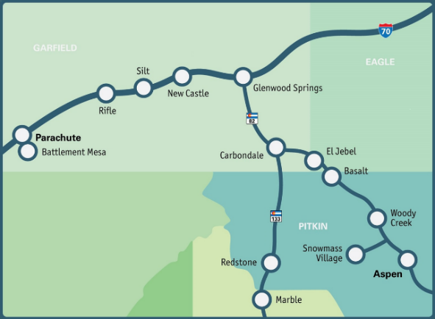
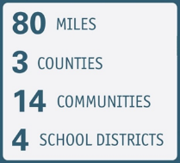
Regional Demographics
Residents from Aspen to Parachute cross municipal, county, and school district boundaries each day for work, school and play establishing an interdependent economic and region. Understanding the diversity and disparities across the region is critical for addressing persistent issues facing youth and families.

POPULATION | Regional | Pitkin | Garfield | RFV Eagle
Total Population | 85,463 | 17,358 | 61,685 | 6,420
Hispanic or Latino (of any race) | 28% | 1,892 | 19,564 | 2,352
Total Households | 33,756 | 8,114 | 23,390 | 2,252
Foreign Born | 11-15% | 10.7% | 14.3% | 15.1%
Not a U.S. Citizen | 36-62% | 36% | 62.7% | ND
Adults with a HS Diploma or Less | 14-24% | 14% | 24.2% | ND
Median Household Income |  | $96,123 | $82,772 | $117,791
Self-sufficiency Standard (2 adults, 1 preschooler, 1 school age) |  | $116,064 | $96,234 | $118,088
Families Living Below the Self-sufficiency Standard | ND | 17.7% | 31.2% | ND
People Who Speak a Language Other Than English at Home | 15-26% | 14.9% | 26% | ND
Without Health Care Coverage | 4-18% | 4.4% | 17.5% | ND
People in Poverty | 7-8% | 6.7% | 8.1% | 8%

CHILDREN AND YOUTH | Region | Pitkin | Garfield | RFV Eagle
Child Population (19 & Under) | 21,197 | 3,060 | 16,799 | 1,338
Young Child Population (Under 5) | 5,135 | 807 | 3,975 | 353
Elementary School Population (Ages 5-9) | 5,152 | 459 | 4,247 | 446
Middle School Population (Ages 10-14) | 5,635 | 879 | 4,438 | 318
High School Population (Ages 15-19) | 5,275 | 915 | 4,139 | 221
Children Under 18 Percent of Population | 25% | 15.8% | 24.6% | 21.4%
Population of Latino Children (Ages 5-18) | 40%
Population of White Children (Ages 5-18) | 57%
School Enrolled Population | ND | 69.3% | 73.3% | 72.7%
Children Under 6 with All Parents in the Workforce | 76%

VULNERABLE CHILDREN AND FAMILIES | Pitkin | Garfield | State | National
Births to Women without a HS Diploma or GED | 12.3% | 16.5% | 10.4%
Teen Birth Rate (per 1,000 Female Teens 15-19) | 7.6 | 18.5 | 11.9
Three Risk Factor Births (Unmarried, Under 25, No Diploma) | 3.8% | 3.4% | 2.8%
Children Living in Poverty (Under 18) | 5.2% | 9.4% | 10.6%

EARLY CARE AND EDUCATION≈ | Pitkin | Garfield | RFV Eagle | Region
Number of Licensed Providers | 13 | 53 | 6 | 72
Licensed Early Childhood Care and Education Capacity | 541 | 1609 | 309 | 2,459
Children Served in Licensed Care | 67% | 40% | 92% | 47%
Average Cost of Care per Month for Preschool-Aged Child | $1,800 | $1,200 | $1,500 | $1,450

VULNERABLE YOUTH (AGES 15-18) | REGION
Students who felt so sad or hopeless almost every day for two weeks or more in a row during the past 12 months that they stopped doing some usual activities | 40.1%
Students who seriously considered attempting suicide during the past 12 months | 16.6%
Students who spent 3+ hours in front of a TV, computer, smart phone, or other electronic device for something other than schoolwork | 70.8%
Students who agree or strongly agree that they belong at their school | 62.9%
Students who participate in extracurricular activities at school | 64%
students who think the things they are learning in school are going to be important or very important for later in life | 55.5%
Students who think it is important or very important to go to college, technical or vocational school | 87.8%
Students who skipped one or more whole days of school during the past four weeks | 24.4%

SCHOOL DISTRICT COMMUNITIES
There are four school districts in the Aspen to Parachute region serving most of the preschool to 12th grade students.
Aspen School District: Snowmass, Woody Creek, Aspen
Roaring Fork School District: Basalt, El Jebel, Carbondale, Redstone, Glenwood Springs
Garfield School District No. RE-2: New Castle, Silt, Rifle
Garfield County School District 16: Parachute, Battlement Mesa
In addition, there are private and state charter schools serving approximately 1,000 pk-12th grade students. Data for students in private or state charter schools is not included in the table below.
SCHOOL DISTRICTS (2023-2024) | Aspen | Roaring Fork | Garfield RE2 | Garfield 16 | Colorado River BOCES  (Yampah HS) | Region
Total District Enrollment | 1,526 | 5,607 | 4,507 | 1,094 | 165 | 12,899
Students Qualifying for Free or Reduced-Price Lunch+ | 6.2% | 50.8% | 34.1% | 67.7% | 27.9% | 40.8%
English Language Learners | 6.2% | 29.5% | 25.3% | 24.4% | 10.3% | 25.8%
Homeless Students (Number)+ | 7 | 83 | 11 | 10 | 11 | 122
Immigrant Children (Number)+ | LNE | 417 | 114 | LNE | LNE | 531
Migrant Children (Number)+ | LNE | LNE | 5 | 5 | LNE | 10
Mobility (Percent of students moving in or out of a district) | 4.4% | 7.4% | 8.4% | 12.6% | 18.2%
Chronic Absenteeism | 42.2% | 33.9% | 29.8% | 41.3% | 11.8%
Students Disciplined | 85 | 643 | 371 | 300 | 6 | 1,405
High School Graduation Rate (4 years) | 92.4% | 82.5% | 83.5% | 84.9% | 75%
Data Notes
Region = Garfield, Pitkin, and Western Eagle counties
LNE = Low Number of Events
ND = No Data
+These programs have stringent criteria, stigmas or are impacted by the political climate which can cause an undercount of students.
≈These numbers include childcare and preschool licensed capacity at all center, district, mobile and home providers within the Aspen to Parachute region

Sources: CECE Coalition, Colorado Center on Law and Policy, Colorado Department of Education, Colorado Department of Public Health and Environment, Healthy Kids Colorado Survey (Region 12: Pitkin, Garfield, Eagle, Summit & Grand counties), Kids Count in Colorado 2022, U.S. Census

